Contents

Chapter 1 3

Introduction 3

1.1 BACKGROUND 3

1.2 OBJECTIVE 4

1.3 Purpose, scope and applicability. 5

Chapter 2 6

System Planning 6

2.1 Survey Of Technologies. 6

2.2 Fact Finding Techniques. 7

2.3 FEASABILITY STUDY: 8

2.4 STAKE-HOLDERS: 10

Chapter 3 11

Requirements and Analysis 11

3.1 PROBLEM DEFINITION: 11

3.2 PLANNING AND SCHEDUELING : 11

3.3 SOFTWARE AND HARDWARE REQUIREMENT: 14

3.5.1 ER Diagram 16

Chapter 4 20

4. SYSTEM DESIGN 20

4.1 Data table constraints and integrity. 21

4.2 DATA DESIGN 21

4.3 User Interface & Design 23

Home Page 23

Registration Page. 23

Login Page 24

Booking Page 24

Service page 25

4.3 Security Issues 25

4.4 Test Cases 27

Chapter 5 28

5. SYSTEM CODING 28

5.1 Coding Details. 28

5.3 Testing Approach 105

Chapter 6 106

Conclusion 106

Chapter 7 107

References 107

# 

# Chapter 1

# Introduction

## 1.1 BACKGROUND

The "Real Estate Management System" has been developed to override the problems

prevailing in the practicing manual system. This software is supported to eliminate and

in some cases reduce the hardships faced by this existing system. Moreover this

system is designed for the particular need of the company to carry out operations in a

smooth and effective manner.

The application is reduced as much as possible to avoid errors while entering the data.

It also provides error message while entering invalid data. No formal knowledge is

needed for the user to use this system. Thus by this all it proves it is user-friendly. Real

Estate Management System, as described above, can lead to error free, secure,

reliable and fast management system. It can assist the user to concentrate on their

other activities rather to concentrate on the record keeping. Thus it will help organization

in better utilization of resources.

Every organization, whether big or small, has challenges to overcome and managing

the information of Property Type, Property, Flats, Facility, Location. Every Real Estate

Management System has different Property needs, therefore we design exclusive

employee management systems that are adapted to your managerial requirements.

This is designed to assist in strategic planning, and will help you ensure that your

organization is equipped with the right level of information and details for your future

goals. Also, for those busy executive who are always on the go, our systems come with

remote access features, which will allow you to manage your workforce anytime, at all

times. These systems will ultimately allow you to better manage resources.

## 1.2 OBJECTIVE

❖ To automate the manual System.

❖ To make the System User Friendly.

❖ Proper validation technique to be used.

❖ Proper security to the data for the access.

The main objective of the Project on Real Estate Management System is to manage the details of Property, Property Type, Property Details, Flats, Location. It manages all the information about Property, Facility, Location, Property.

## 1.3 Purpose, scope and applicability.

**1.3.1 Purpose**

The Real Estate Management System is designed in order to eliminate the problem of the current system. This accessibility of the information will be a great advantage as it reduced effort.

The system handles all aspects of viewing and bidding of the property. It allows the seller to post the property, delete the property and modify the current property.

**1.3.2 Scope**

It may help collecting perfect management in details. In a very short time, the collection will be obvious, simple and sensible. It will help a person to know the management of passed year perfectly and vividly. It also helps in current all works relative to Real Estate Management System. It will be also reduced the cost of collecting the management & collection procedure will go on smoothly.

**1.3.3 APPLICABILITY**

* The first advantage of the proposed system is that its front end provide easy and precised information to the user to interact with the system and hence it is faster to complete thework
* The next advantage of the present system is that its faster capability with the database. Even the database also provides its inbuilt features to maintain the records. It alsoprovides security to the records from the system itself and also from the database itself. Hence it prevents the database conjunction
* The present system provides the better screening of the record, another advantage of the proposed system is its faster capability to search the records from the database.

# Chapter 2

# System Planning

## 2.1 Survey Of Technologies.

The technologies used to develop the website are:

* Frontend Tool: html, CSS, JavaScript.
* Backend Tool: C#, MySQL.
* Database : MS SQL Server.
* Technologies: ASP.NET.

C# is a multi-paradigm programming language encompassing strong typing,

imperative, declarative, functional, generic, object-oriented (class-based), and

component-oriented programming disciplines. It was developed by Microsoft

within its .NET initiative and later approved as a standard by Ecma and ISO. C# is

one of the programming languages designed for the Common Language

Infrastructure.

ASP.NET Core is a cross-platform, high-performance, open-source framework for building modern, cloud-enabled, Internet-connected apps.

With ASP.NET Core, you can:

● Build web apps and services, Internet of Things (IoT) apps, and mobile backends.

● Use your favourite development tools on Windows, macOS, and Linux.

● Deploy to the cloud or on-premises.

● Run on .NET Core.

## 2.2 Fact Finding Techniques.

Fact finding is process of collection of data and information based on techniques which contain sampling of existing documents, research, observation, questionnaires, interviews, prototyping and joint requirements planning. System analyst uses suitable fact-finding techniques to develop and implement the current existing system. Collecting required facts are very important to apply tools in **System Development Life Cycle (SDLC)** because tools cannot be used efficiently and effectively without proper extracting from facts. Fact-finding techniques are used in the early stage of System Development Life Cycle including system analysis phase, design and post implementation review. Facts included in any information system can be tested based on three steps: data- facts used to create useful information, process- functions to perform the objectives and interface- designs to interact with users.

● A sampling of existing documentation, forms, and databases.

● Research and Site visits.

● Observation of the work environment .

● Questionnaires.

● Interviews .

● Prototyping.

● Joint requirements planning.

## 2.3 FEASABILITY STUDY:

Preliminary investigation examine project feasibility, the likelihood the system will be useful to the organization. The main objective of the feasibility study is to test the Technical, Operational and Economical feasibility for adding new modules and debugging old running system. All system is feasible if they are unlimited resources and

infinite time. There are aspects in the feasibility study portion of the preliminary

investigation:

* **Technical Feasibility:**

The technical issue usually raised during the feasibility stage of the investigation

includes the following:

* Does the necessary technology exist to do what is suggested?
* Do the proposed equipment’s have the technical capacity to hold the data required to use the new system?
* Will the proposed system provide adequate response to inquiries, regardless of the
* number or location of users?
* Can the system be upgraded if developed?
* Are there technical guarantees of accuracy, reliability, ease of access and data
* security?
* **Operational Feasibility:**

Proposed projects are beneficial only if they can be turned out into information

system. That will meet the organization’s operating requirements. Operational feasibility aspects of the project are to be taken as an important part of the project implementation.

Some of the important issues raised are to test the operational feasibility of a project

includes the following: -

* Is there sufficient support for the management from the users?
* Will the system be used and work properly if it is being developed and implemented?
* Will there be any resistance from the user that will undermine the possible application benefits?
* This system is targeted to be in accordance with the above-mentioned issues.

Beforehand, the management issues and user requirements have been taken into

consideration. So there is no question of resistance from the users that can undermine the

possible application benefits.

* **Economical Feasibility:**

A system can be developed technically and that will be used if installed must still

be a good investment for the organization. In the economical feasibility, the development

cost in creating the system is evaluated against the ultimate benefit derived from the new

systems. Financial benefits must equal or exceed the costs.

The system is economically feasible. It does not require any addition hardware or

software. Since the interface for this system is developed using the existing resources and

technologies available at NIC, There is nominal expenditure and economical feasibility

for certain.

## 2.4 STAKE-HOLDERS:

Stakeholders are individuals who either care about or have a vested interest in your project. They are the people who are actively involved with the work of the project or have something to either gain or lose as a result of the project.

Project Stakeholders

**Top Management :**

Top management may include the president of the company, vice-presidents, directors, division managers, the corporate operating committee, and others. These people direct the strategy and development of the organization.

**Developers** :

The developers are the ones who design, test and maintain the project.

**Users :**

User are those group of people who will use the website.

**Investor:**

Investors are those who invest their money in our website for their profits.

# Chapter 3

# Requirements and Analysis

## 3.1 PROBLEM DEFINITION:

The Existing system being manual is a slow and moreover it’s very difficult to access the reports of connections and transactions. Thus, for accurate and fast retrieval of reports the system was to be automated.

Disadvantages of the existing system:

* Slow response aboutrefunding.
* No information regarding any products to the customer.
* At present there is a manual system used to maintain all customer details.
* Complicated to manage the payment and customer details.
* In the manual system there is no safety related to data security.

## 3.2 PLANNING AND SCHEDUELING :

Planning and scheduling are a complicated part of software development. Planning, for our purposes, can be thought of as determining all the small tasks that must be carried out in order to accomplish the goal. Planning also takes into account, rules, known as constraints, which, control when certain tasks can or cannot happen.

Scheduling can be thought of as determining whether adequate resources are available to carry out the plan. Purpose of planning and scheduling is that to finish work properly in the given time period.

For our project, planning was started from the month of June. In the planning process, we have discussed about the project purpose, reason of the existence, comparison with the existing work and the new thing to be developed in the beginning part. In the later section, after having the clear vision of the project, we started working on documentation. During the planning part, we have also discussed about the software and hardware requirement and the languages required for coding.

After all the planning part is done, according to it scheduling of work was started. In this part, time and resources are distributed according to our requirement. Purpose of scheduling is that, the work should be done without any obstacles for example, overlapping two works at the same time or same resource shouldn’t be used at two different places at the same time. To avoid this circumstance, planningand scheduling is done

**Gantt Chart:**

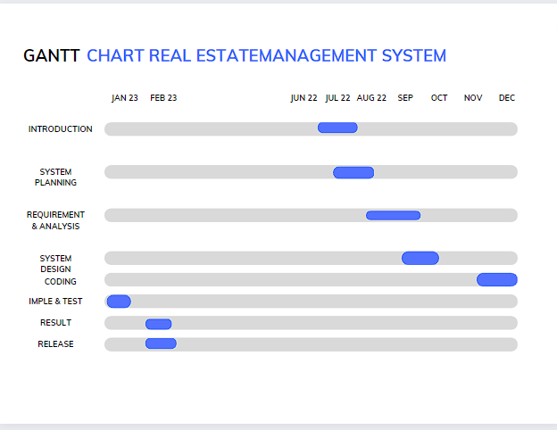

## 3.3 SOFTWARE AND HARDWARE REQUIREMENT:

**3.3.1. Hardware Requirement**

* Processor: Intel Pentium III Hard
* Disk Drive: 500 GigaBytes
* RAM: 4 GB

**Minimum Software Requirement**

* Operating System: WINDOWS 7 Front-End:
* C# Back-End: ASP.NET
* Database: Microsoft SQL server
* Platform: Visual Studio 2022

**3.3.1.1. Server Side**

* PROCESSOR: -Server Environment Capable H/W
* RAM: -2GB RAM
* DISK SPACE: -As per the size of requirements DBMS

**3.3.1.2. Client Side**

* PROCESSOR: -Desktop
* RAM: -2GB RAM
* DISK SPACE: -As per the size of requirements DBMS

**3.3.2.2. Client Side**

* Operating System (Windows/MacOS/Linux)
* Web Browser (Google Chrome / Mozilla Firefox / Apple Safari / Microsoft Edge)

**3.4 CONCEPTUAL DIAGRAM.**

A conceptual model is a representation of a system, made of the composition of concepts which are used to help people know, understand, or simulate a subject the model represents. It is also a set of concepts.

Conceptual modelling is a crucial software development activity. Conceptual models give you background details about the project work. It tells you about the resources, criteria, requirements, involvements of people, process, etc.

### 3.4.1 ER Diagram

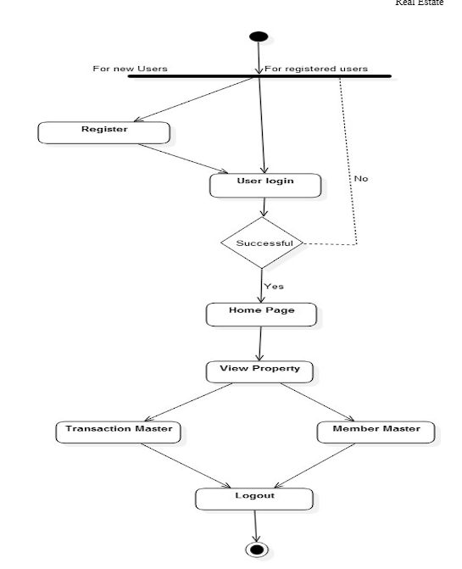

### 3.4.2 USE CASE DIAGRAM

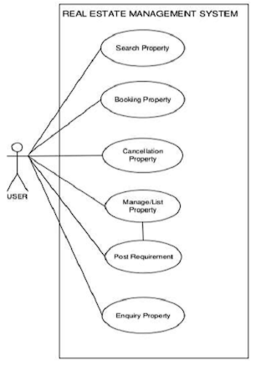

### 3.5.3 CLASS DIAGRAM

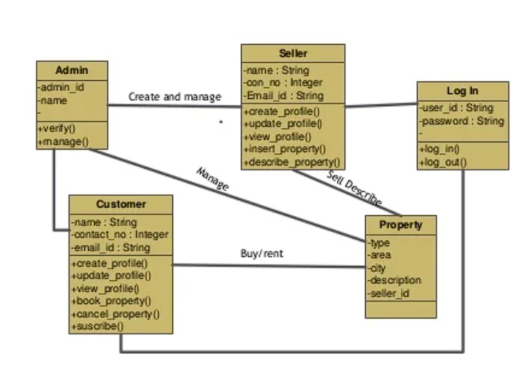

### 3.5.4 COMPONENT DIAGRAM

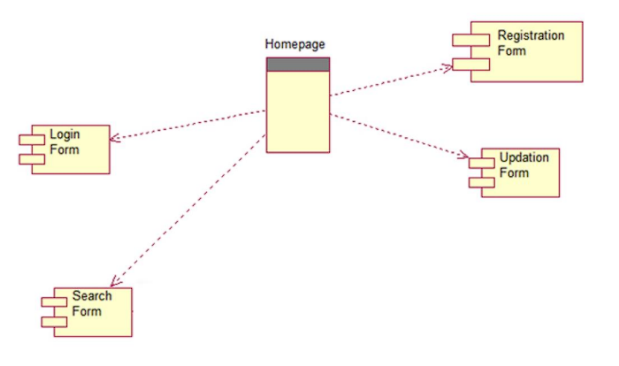

### 3.5.5 SYSTEM FLOWCHART

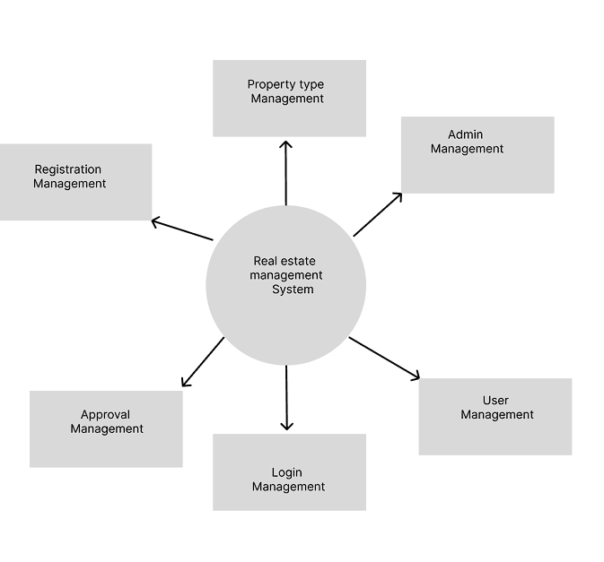

# Chapter 4

# SYSTEM DESIGN

System design is the solution of a “how to approach to the creation of the new system. It is composed of several steps. It facilitates the understanding and provides the procedural details necessary for implementation of the system recommended in the feasibility study. Emphasis is given on translating the performance requirements into design specification. Design goes through logical and physical stages of development.

Logical design reviews the present physical system; prepares input and output specification; make editing; security and control specification; details the implementation plan, and prepare logical design walk through. The physical design maps out the details of the physical system; plans the system implementation plan and specifies hardware and software. System design translates the system requirement into the ways of the system as recommended in the feasibility study. Thus the system design is the translation from user-oriented document to a programmer or a database personal oriented document. System design is a highly creative process that can be greatly facilitated by the following:-

• Strong Problem Definition

• Pictorial description of the Existing System

• Set of Requirements of the new system

## 4.1 Data table constraints and integrity.

The general theme behind a database is to handle information as an integrated whole. A database is a collection of inter-related data stored with minimum redundancy to serve single users quickly and efficiently. The general objective is to make information necessary, quick, inexpensive and flexible for the user

## 4.2 DATA DESIGN----Booking_Tbl

|  |  |
| --- | --- |
| Bid | integer |
| Action | Varchar |
| Type | varchar |
| Cities | Varchar |
| Rooms | integer |
| Bed | integer |
| Bath | integer |
| name | Varchar(30) |

**User_Tbl**

|  |  |
| --- | --- |
| uid | integer |
| Fname | varchar |
| lname | lname |
| gender | Varchar |
| mobile | integer |
| email | varchar |
| username | varchar |
| pass | varchar |

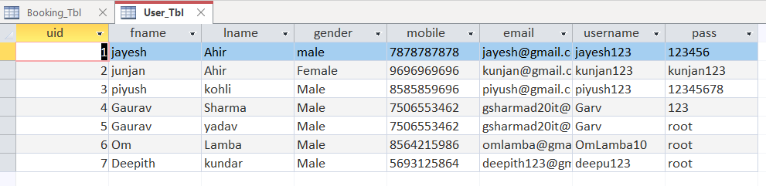

## 4.3 User Interface & Design

### Home Page

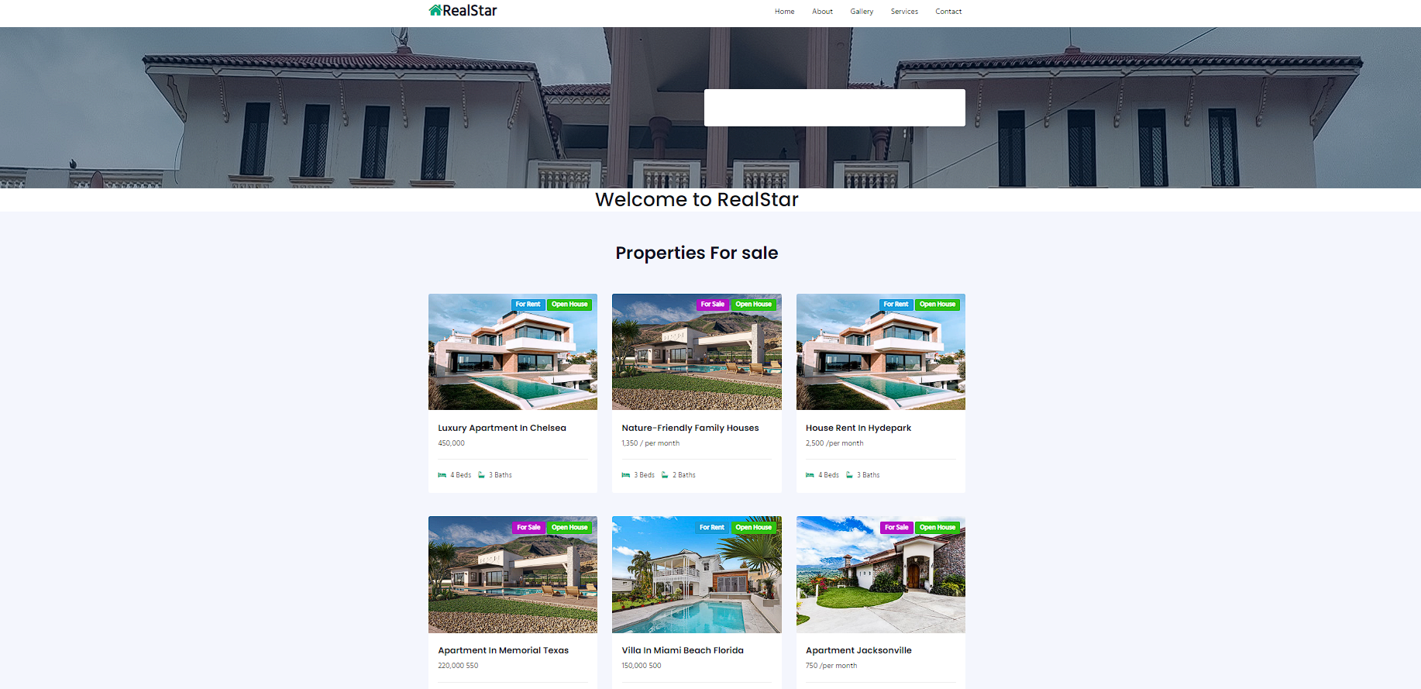

### Registration Page.

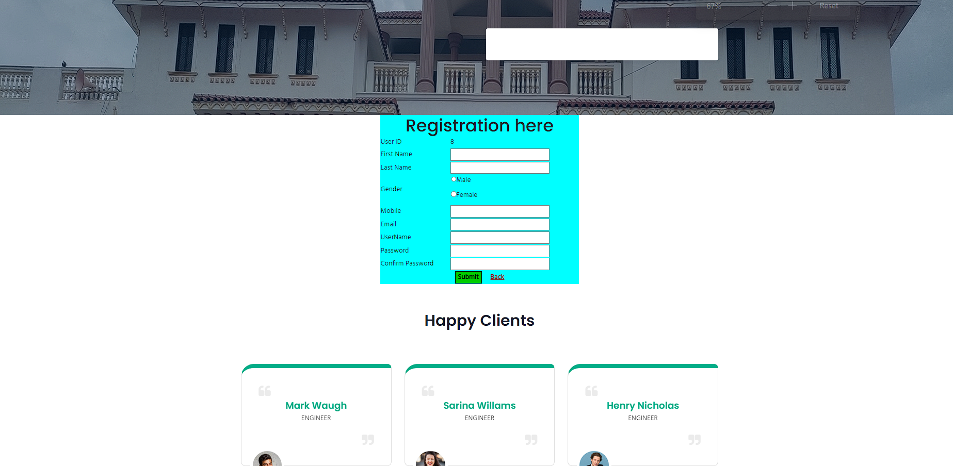

### Login Page

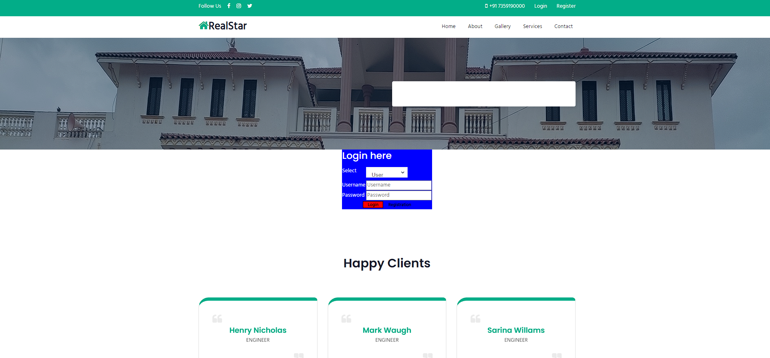

### Booking Page

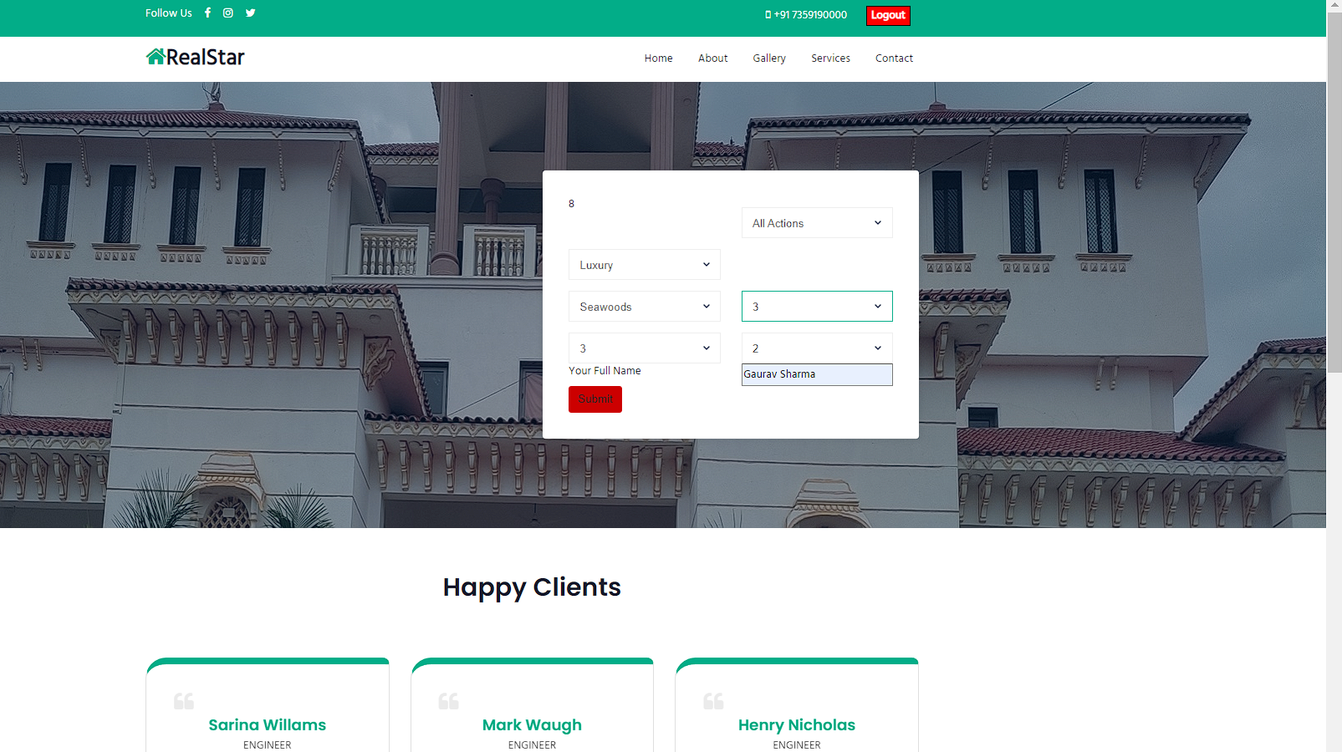

Service page

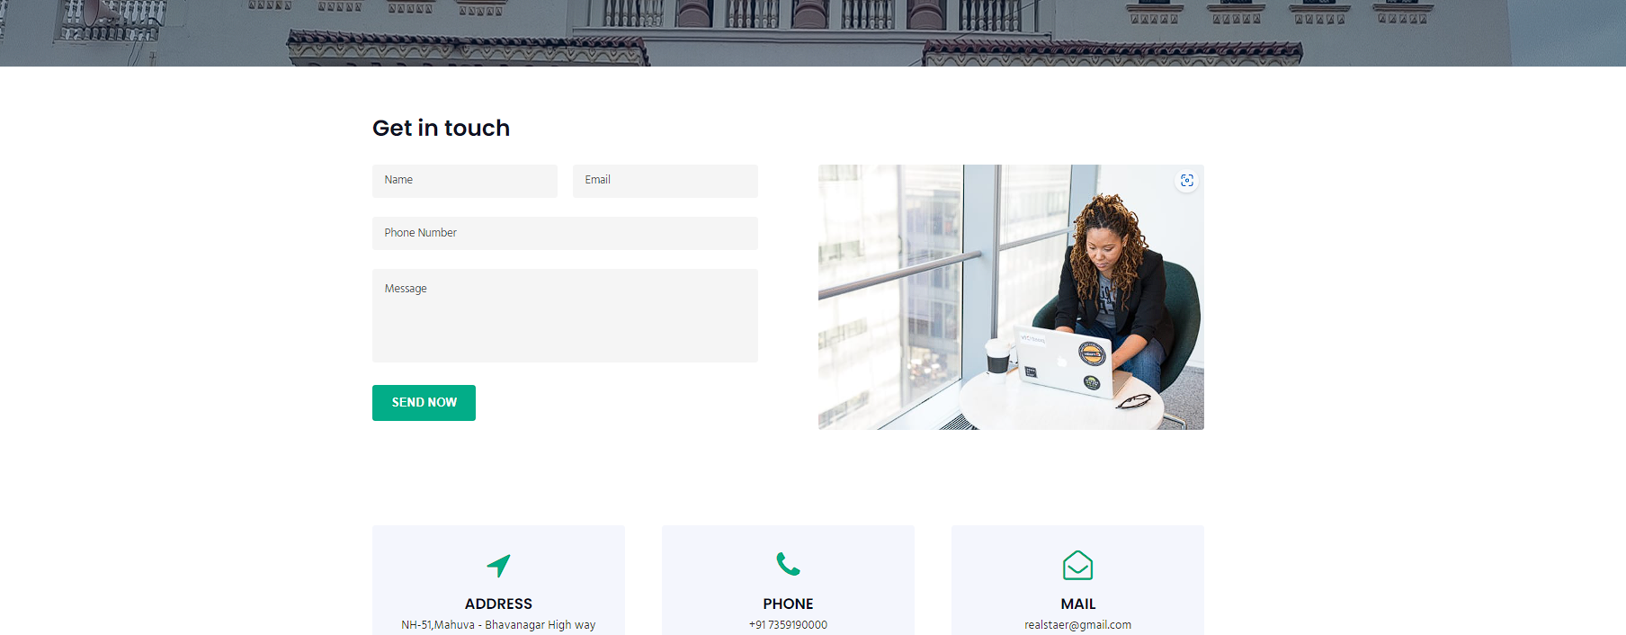

## 4.3 Security Issues

**Most Common Website Security Issues**

**1. Injection attacks:** Injection attacks occur when an attacker injects malicious code into a website's input fields or parameters, allowing them to execute commands or access data they shouldn't have access to.

**2. Cross-site scripting (XSS):** Cross-site scripting is a type of attack that allows an attacker to inject malicious code into a website that is executed by other users' browsers. This can allow an attacker to steal sensitive information, such as login credentials or payment information.

**3. Cross-site request forgery (CSRF):** CSRF is a type of attack that tricks a user into performing an action on a website without their knowledge or consent. This can allow an attacker to perform actions such as transferring funds or changing passwords.

**4. Broken authentication and session management:** If a website's authentication and session management systems are not implemented correctly, attackers can gain unauthorized access to user accounts, bypass authentication mechanisms, or steal session tokens.

**5. Security misconfigurations:** Security misconfigurations occur when a website's security settings are not configured correctly, leaving it vulnerable to attacks. This can include things like leaving default passwords in place, not keeping software up to date, or leaving sensitive files accessible to the public.

**6. Insecure direct object references:** Insecure direct object references occur when a website exposes a reference to an internal object, such as a file or database record, to the user. This can allow an attacker to manipulate these references and gain unauthorized access to sensitive data.

**7. Insufficient encryption and data protection:** If a website does not use encryption or data protection mechanisms correctly, attackers can intercept sensitive data such as login credentials or payment information. This can result in identity theft or financial loss for users. lOMoAR cPSD|16868877 38

**8. Malware and viruses:** Websites can be infected with malware or viruses, which can be used to steal data, take control of user devices, or launch attacks against other websites or networks. This can happen if the website's software is not kept up to date, or if users are tricked into downloading malicious files.

**9. Denial of service (DoS) attacks:** DoS attacks occur when an attacker overwhelms a website's server with traffic, rendering it unavailable to legitimate users. This can cause significant damage to a website's reputation and can result in lost revenue for the website owner.

## 4.4 Test Cases

**Use Case Testing**

Use Case Testing for User Login

# Chapter 5

# SYSTEM CODING

### 5.1 Coding Details.

### Home.aspx

<%@ Page Title="Home" Language="C#" MasterPageFile="~/Usre/users.Master" AutoEventWireup="true" CodeBehind="Home.aspx.cs" Inherits="Realstate_Application.Usre.WebForm1" %>

<asp:Content ID="Content1" ContentPlaceHolderID="ContentPlaceHolder1" runat="server">

<center>

<h1>Welcome to RealStar </h1>

</center>

<section class="grids-4" id="properties">

<div id="grids4-block" class="py-5">

<div class="container py-md-3">

<div class="heading text-center mx-auto">

<h3 class="head">Properties For sale</h3>

<p class="my-3 head"> </p>

</div>

<div class="row mt-5 pt-3">

<div class="grids4-info col-lg-4 col-md-6">

<a href="#"><img src="assets/images/g7.jpg" class="img-fluid" alt=""></a>

<ul class="location-top">

<li class="rent">For Rent</li>

<li class="open-1">Open House</li>

</ul>

<div class="info-bg">

<h5><a href="#">Luxury Apartment In chelsea</a></h5>

<p> 450,000 </p>

<ul>

<li><span class="fa fa-bed"></span> 4 Beds</li>

<li><span class="fa fa-bath"></span> 3 Baths</li>

</ul>

</div>

</div>

<div class="grids4-info col-lg-4 col-md-6 mt-md-0 mt-5">

<a href="#"><img src="assets/images/g8.jpg" class="img-fluid" alt=""></a>

<ul class="location-top">

<li class="sale">For Sale</li>

<li class="open-1">Open House</li>

</ul>

<div class="info-bg">

<h5><a href="#">Nature-Friendly Family Houses</a></h5>

<p> 1,350 / per month</p>

<ul>

<li><span class="fa fa-bed"></span> 3 Beds</li>

<li><span class="fa fa-bath"></span> 2 Baths</li>

</ul>

</div>

</div>

<div class="grids4-info col-lg-4 col-md-6 mt-lg-0 mt-5">

<a href="#"><img src="assets/images/g7.jpg" class="img-fluid" alt=""></a>

<ul class="location-top">

<li class="rent">For Rent</li>

<li class="open-1">Open House</li>

</ul>

<div class="info-bg">

<h5><a href="#">House Rent in Hydepark</a></h5>

<p> 2,500 /per month</p>

<ul>

<li><span class="fa fa-bed"></span> 4 Beds</li>

<li><span class="fa fa-bath"></span> 3 Baths</li>

</ul>

</div>

</div>

<div class="grids4-info col-lg-4 col-md-6 mt-5">

<a href="#"><img src="assets/images/g8.jpg" class="img-fluid" alt=""></a>

<ul class="location-top">

<li class="sale">For Sale</li>

<li class="open-1">Open House</li>

</ul>

<div class="info-bg">

<h5><a href="#">Apartment in Memorial Texas</a></h5>

<p> 220,000 550</p>

<ul>

<li><span class="fa fa-bed"></span> 5 Beds</li>

<li><span class="fa fa-bath"></span> 3 Baths</li>

</ul>

</div>

</div>

<div class="grids4-info col-lg-4 col-md-6 mt-5">

<a href="#"><img src="assets/images/g9.jpg" class="img-fluid" alt=""></a>

<ul class="location-top">

<li class="rent">For Rent</li>

<li class="open-1">Open House</li>

</ul>

<div class="info-bg">

<h5><a href="#">Villa in Miami beach Florida</a></h5>

<p> 150,000 500 </p>

<ul>

<li><span class="fa fa-bed"></span> 2 Beds</li>

<li><span class="fa fa-bath"></span> 1 Baths</li>

</ul>

</div>

</div>

<div class="grids4-info col-lg-4 col-md-6 mt-5">

<a href="#"><img src="assets/images/g10.jpg" class="img-fluid" alt=""></a>

<ul class="location-top">

<li class="sale">For Sale</li>

<li class="open-1">Open House</li>

</ul>

<div class="info-bg">

<h5><a href="#">Apartment Jacksonville</a></h5>

<p> 750 /per month</p>

<ul>

<li><span class="fa fa-bed"></span> 4 Beds</li>

<li><span class="fa fa-bath"></span> 3 Baths</li>

</ul>

</div>

</div>

</div>

</div>

</div>

</section>

</asp:Content>

### About.aspx

<%@ Page Title="About" Language="C#" MasterPageFile="~/Usre/users.Master" AutoEventWireup="true" CodeBehind="About.aspx.cs" Inherits="Realstate_Application.Usre.WebForm5" %>

<asp:Content ID="Content1" ContentPlaceHolderID="ContentPlaceHolder1" runat="server">

<center>

<h2>User/About</h2>

</center>

<section class="w3l-services2" id="services">

<div class="features-with-17_sur py-5">

<div class="container py-md-3">

<div class="heading text-center mx-auto">

<h3 class="head text-white">What We Offer</h3>

<p class="my-3 head "> </p>

</div>

<div class="row pt-5 mt-3">

<div class="col-lg-5 features-with-17-left_sur">

<h4 class="lft-head">We’re Offering Unmatched Services</h4>

<p></p>

<div class="stats-1">

<div class="stats-1-left">

<h4>2300</h4>

<h6>Clients</h6>

</div>

<div class="stats-1-left">

<h4>16</h4>

<h6>Awards</h6>

</div>

<div class="stats-1-left">

<h4>2536</h4>

<h6>Projects</h6>

</div>

</div>

</div>

<div class="col-lg-7 my-lg-0 my-5 align-self-center features-with-17-right_sur">

<div class="features-with-17-right-tp_sur">

<div class="features-with-17-left1">

<span class="fa fa-laptop s4"></span>

</div>

<div class="features-with-17-left2">

<h6><a href="#url">Fastest Service</a></h6>

<p></p>

</div>

</div>

<div class="features-with-17-right-tp_sur">

<div class="features-with-17-left1">

<span class="fa fa-database s5"></span>

</div>

<div class="features-with-17-left2">

<h6><a href="#url">Largest Real Estate</a></h6> <p></p>

</div>

</div>

<div class="features-with-17-right-tp_sur">

<div class="features-with-17-left1">

<span class="fa fa-lock s3"></span>

</div>

<div class="features-with-17-left2">

<h6><a href="#url">Property Insurance</a></h6>

<p></p>

</div>

</div>

<div class="features-with-17-right-tp_sur">

<div class="features-with-17-left1">

<span class="fa fa-codepen s2"></span>

</div>

<div class="features-with-17-left2">

<h6><a href="#url">Doorstep Process</a></h6>

<p></p>

</div>

</div> </div>

</div>

</div>

</div>

</section>

</asp:Content>

### Contact.aspx

<%@ Page Title="Contact" Language="C#" MasterPageFile="~/Usre/users.Master" AutoEventWireup="true" CodeBehind="Contact.aspx.cs" Inherits="Realstate_Application.Usre.WebForm4" %>

<asp:Content ID="Content1" ContentPlaceHolderID="ContentPlaceHolder1" runat="server">

<!-- contact form -->

<section class="w3l-contacts-2" id="contact">

<div class="contacts-main">

<div class="form-41-mian py-5">

<div class="container py-md-3">

<h3 class="cont-head">Get in touch</h3>

<div class="d-grid align-form-map">

<div class="form-inner-cont">

<form action="https://sendmail.w3layouts.com/submitForm" method="post" class="main-input">

<div class="top-inputs d-grid">

<input type="text" placeholder="Name" name="w3lName" id="w3lName" required="">

<input type="email" name="email" placeholder="Email" id="w3lSender" required="">

</div>

<input type="text" placeholder="Phone Number" name="w3lName" id="w3lName" required="">

<textarea placeholder="Message" name="w3lMessage" id="w3lMessage" required=""></textarea>

<div class="text-right">

<button type="submit" class="btn btn-theme3">Send Now</button>

</div>

</form>

</div>

<div class="contact-right">

<img src="assets/images/ab-2.jpg" class="img-fluid" alt="">

</div>

</div>

</div>

</div>

<div class="contant11-top-bg py-5">

<div class="container py-md-3">

<div class="d-grid contact section-gap">

<div class="contact-info-left d-grid text-center">

<div class="contact-info">

<span class="fa fa-location-arrow" aria-hidden="true"></span>

<h4>Address</h4>

<p>NH-51,Mahuva - Bhavanagar High way Road To: Bhavanagar</p>

</div>

<div class="contact-info">

<span class="fa fa-phone" aria-hidden="true"></span>

<h4>Phone</h4>

<p><a href="tel:+91 7359000000">+91 7359190000</a></p>

</div>

<div class="contact-info">

<span class="fa fa-envelope-open-o" aria-hidden="true"></span>

<h4>Mail</h4>

<p><a href="#" class="email">realstaer@gmail.com</a></p>

</div>

</div>

</div>

</div>

</div>

</section>

<!-- //contact form -->

</asp:Content>

### Login.aspx

<%@ Page Title="Login" Language="C#" MasterPageFile="~/Usre/users.Master" AutoEventWireup="true" CodeBehind="Login.aspx.cs" Inherits="Realstate_Application.Usre.WebForm6" %>

<asp:Content ID="Content1" ContentPlaceHolderID="ContentPlaceHolder1" runat="server">

<center style="height: 250px">

<table style="background-color: #0000FF; color: #FFFFFF" >

<tr>

<th align="center" colspan="2"><h3>Login here</h3></th>

</tr>

<tr>

<td>Select</td>

<td>

<asp:DropDownList ID="DropDownList1_login" runat="server" Height="31px" Width="122px">

<asp:ListItem>User</asp:ListItem>

<asp:ListItem>Admin</asp:ListItem>

</asp:DropDownList></td>

</tr>

<tr>

<td>Username</td>

<td>

<asp:TextBox ID="txt_usernam_signin" runat="server" Placeholder="Username"></asp:TextBox></td>

</tr>

<tr>

<td>Password</td>

<td> <asp:TextBox ID="txt_pass_signin" runat="server" TextMode="Password" placeholder="Password"></asp:TextBox></td>

</tr>

<tr>

<td colspan="2" align="center">

<asp:Button ID="Button_signin" runat="server" Text="Login" BackColor="Red" Font-Bold="True" Font-Size="Smaller" Height="21px" Width="60px" OnClick="Button_signin_Click" />&nbsp&nbsp&nbsp <asp:LinkButton ID="LinkButton1_register" runat="server" Font-Bold="True" Font-Size="Small" OnClick="LinkButton1_register_Click">Registration</asp:LinkButton></td>

</tr>

</table>

</center>

</asp:Content>

### Gallery.aspx

<%@ Page Title="Gallery" Language="C#" MasterPageFile="~/Usre/users.Master" AutoEventWireup="true" CodeBehind="Gallery.aspx.cs" Inherits="Realstate_Application.Usre.WebForm2" %>

<asp:Content ID="Content1" ContentPlaceHolderID="ContentPlaceHolder1" runat="server">

<section class="locations-1" id="locations">

<div class="locations py-5">

<div class="container py-md-3">

<div class="heading text-center mx-auto">

<h3 class="head">Popular Locations</h3>

<p class="my-3 head "></p>

</div>

<div class="row mt-3 pt-5">

<div class="col-md-4 col-sm-6">

<div class="box16">

<img class="img-fluid" src="assets/images/g1.jpg" alt="">

<div class="box-content">

<h3 class="title">Agra</h3>

<span class="post">2 Listings</span>

</div>

</div>

</div>

<div class="col-md-4 col-sm-6">

<div class="box16">

<img class="img-fluid" src="assets/images/g2.jpg" alt="">

<div class="box-content">

<h3 class="title">Benglore</h3>

<span class="post">2 Listings</span>

</div>

</div>

</div>

<div class="col-md-4 col-sm-6 mt-lg-0 pt-lg-0 mt-md-4 pt-md-2">

<div class="box16">

<img class="img-fluid" src="assets/images/g3.jpg" alt="">

<div class="box-content">

<h3 class="title">Surat</h3>

<span class="post">2 Listings</span>

</div>

</div>

</div>

<div class="col-md-4 col-sm-6 mt-md-4 pt-md-2">

<div class="box16">

<img class="img-fluid" src="assets/images/g4.jpg" alt="">

<div class="box-content">

<h3 class="title">Ahmdabad</h3>

<span class="post">2 Listings</span>

</div>

</div>

</div>

<div class="col-md-4 col-sm-6 mt-md-4 pt-md-2">

<div class="box16">

<img class="img-fluid" src="assets/images/g5.jpg" alt="">

<div class="box-content">

<h3 class="title">Mumbai</h3>

<span class="post">2 Listings</span>

</div>

</div>

</div>

<div class="col-md-4 col-sm-6 mt-md-4 pt-md-2">

<div class="box16">

<img class="img-fluid" src="assets/images/g6.jpg" alt="">

<div class="box-content">

<h3 class="title">New Jaypur</h3>

<span class="post">2 Listings</span>

</div>

</div>

</div>

</div>

</div>

</div>

</section>

</asp:Content>

### main_Booking_web.aspx

<%@ Page Language="C#" AutoEventWireup="true" CodeBehind="main_Booking_web.aspx.cs" Inherits="Realstate_Application.Usre.main_Booking_web" %>

<!DOCTYPE html>

<html xmlns="http://www.w3.org/1999/xhtml">

<head runat="server">

<title>Booking</title>

<!-- Required meta tags -->

<meta charset="utf-8"/>

<meta name="viewport" content="width=device-width, initial-scale=1, shrink-to-fit=no"/>

<!-- web fonts -->

<link href="//fonts.googleapis.com/css?family=Poppins:300,400,500,600,700,800,900&display=swap" rel="stylesheet"/>

<link href="//fonts.googleapis.com/css?family=Hind&display=swap" rel="stylesheet"/>

<!-- //web fonts -->

<!-- Template CSS -->

<link rel="stylesheet" href="assets/css/style-starter.css"/>

</head>

<body>

<form id="form1" runat="server">

<div>

<!-- Top Menu 1 -->

<section class="w3l-top-menu-1">

<div class="top-hd">

<div class="container">

<header class="row">

<div class="social-top col-lg-3 col-6">

<li>Follow Us</li>

<li><a href="#"><span class="fa fa-facebook"></span></a></li>

<li><a href="#"><span class="fa fa-instagram"></span></a> </li>

<li><a href="#"><span class="fa fa-twitter"></span></a></li>

</div>

<div class="accounts col-lg-9 col-6">

<li class="top_li"><span class="fa fa-mobile"></span><a href="tel:+91 7359000000">+91 7359190000</a> </li>

<li class="top_li1"><a>

<asp:Button ID="btn_login" runat="server" Text="Logout" BackColor="Red" Font-Bold="True" ForeColor="White" OnClick="btn_login_Click" /></a></li>

</div>

</header>

</div>

</div>

</section>

<!-- //Top Menu 1 -->

<section class="w3l-bootstrap-header">

<nav class="navbar navbar-expand-lg navbar-light py-lg-2 py-2">

<div class="container">

<a class="navbar-brand" href="Home.aspx"><span class="fa fa-home"></span>RealStar</a>

<button class="navbar-toggler" type="button" data-toggle="collapse" data-target="#navbarSupportedContent"

aria-controls="navbarSupportedContent" aria-expanded="false" aria-label="Toggle navigation">

<span class="navbar-toggler-icon fa fa-bars"></span>

</button>

<div class="collapse navbar-collapse" id="navbarSupportedContent">

<ul class="navbar-nav ml-auto">

<li class="nav-item">

<a class="nav-link" href="Home.aspx">Home</a>

</li>

<li class="nav-item">

<a class="nav-link" href="About.aspx">About</a>

</li>

<li class="nav-item">

<a class="nav-link" href="Gallery.aspx">Gallery</a>

</li>

<li class="nav-item">

<a class="nav-link" href="Services.aspx">Services</a>

</li>

<li class="nav-item mr-0">

<a class="nav-link" href="Contact">Contact</a>

</li>

</ul>

</div>

</div>

</nav>

</section>

<section class="form-12" id="home">

<div class="form-12-content">

<div class="container">

<div class="grid grid-column-2 ">

<div class="column2">

</div>

<div class="column1">

<form action="/" method="Get">

<div class="form-top">

<asp:Label ID="Label1" runat="server" Text="Label"></asp:Label>

<asp:DropDownList ID="DropDownList_01" runat="server">

<asp:ListItem>All Actions</asp:ListItem>

<asp:ListItem>Rent</asp:ListItem>

<asp:ListItem>Sale</asp:ListItem>

<asp:ListItem>Sold Out</asp:ListItem>

</asp:DropDownList>

<asp:DropDownList ID="DropDownList_02" runat="server">

<asp:ListItem>All Types</asp:ListItem>

<asp:ListItem>Apartment</asp:ListItem>

<asp:ListItem>Business</asp:ListItem>

<asp:ListItem>House</asp:ListItem>

<asp:ListItem>Luxury</asp:ListItem>

<asp:ListItem>Residential</asp:ListItem>

<asp:ListItem>Restaurant</asp:ListItem>

<asp:ListItem>Single Family</asp:ListItem>

<asp:ListItem>Villa</asp:ListItem>

</asp:DropDownList>

</div>

<div class="form-top"> <asp:DropDownList ID="DropDownList_03" runat="server">

<asp:ListItem>All Cities</asp:ListItem>

<asp:ListItem>Vashi</asp:ListItem>

<asp:ListItem>Seawoods</asp:ListItem>

<asp:ListItem>Lonavla</asp:ListItem>

<asp:ListItem>Mahabaleshwar</asp:ListItem>

<asp:ListItem>Kharghar</asp:ListItem>

</asp:DropDownList>

<asp:DropDownList ID="DropDownList_04" runat="server">

<asp:ListItem>Min Room</asp:ListItem>

<asp:ListItem>All Rooms</asp:ListItem>

<asp:ListItem>1</asp:ListItem>

<asp:ListItem>2</asp:ListItem>

<asp:ListItem>3</asp:ListItem>

<asp:ListItem>4</asp:ListItem>

<asp:ListItem>5</asp:ListItem>

<asp:ListItem>6</asp:ListItem>

</asp:DropDownList>

</div>

<div class="form-top">

<asp:DropDownList ID="DropDownList_05" runat="server">

<asp:ListItem>All Bed Rooms</asp:ListItem>

<asp:ListItem>Min Bed Rooms</asp:ListItem>

<asp:ListItem>1</asp:ListItem>

<asp:ListItem>2</asp:ListItem>

<asp:ListItem>3</asp:ListItem>

<asp:ListItem>4</asp:ListItem>

<asp:ListItem>5</asp:ListItem>

<asp:ListItem>6</asp:ListItem>

</asp:DropDownList>

<asp:DropDownList ID="DropDownList_06" runat="server">

<asp:ListItem>All Baths</asp:ListItem>

<asp:ListItem>Min Baths</asp:ListItem>

<asp:ListItem>1</asp:ListItem>

<asp:ListItem>2</asp:ListItem>

<asp:ListItem>3</asp:ListItem>

<asp:ListItem>4</asp:ListItem>

<asp:ListItem>5</asp:ListItem>

<asp:ListItem>6</asp:ListItem>

</asp:DropDownList>

</div>

<div class="form-top">

<label>Your Full Name</label>

<asp:TextBox ID="txt_fulll_name" runat="server"></asp:TextBox>

</div>

<asp:Button ID="btn_booking" class="btn" runat="server" Text="Submit" BackColor="#CC0000" OnClick="btn_booking_Click" /> </form>

</div>

</div>

</div>

</div>

<section class="w3l-testimonials" id="testimonials">

<div class="customers-6-content py-5">

<div class="container py-lg-3">

<div class="heading text-center mx-auto">

<h3 class="head">Happy Clients</h3>

<p class="my-3 head "> </p>

</div>

<div id="customerhnyCarousel" class="carousel slide" data-ride="carousel">

<ol class="carousel-indicators">

<li data-target="#customerhnyCarousel" data-slide-to="0" class="active"></li>

<li data-target="#customerhnyCarousel" data-slide-to="1"></li>

<li data-target="#customerhnyCarousel" data-slide-to="2"></li>

</ol>

<!-- Carousel items -->

<div class="carousel-inner pb-5">

<div class="carousel-item active">

<div class="customer row py-5 mt-3">

<div class="col-lg-4 col-md-6">

<div class="card">

<img class="card-img-top img-responsive" src="assets/images/c1.jpg" alt="">

<div class="card-body">

<span class="fa fa-quote-left" aria-hidden="true"></span>

<h3 class="card-title">Henry Nicholas</h3>

<p class="sub-title mb-3">Engineer</p>

<p class="card-text text-center mb-4">

</p>

<div class="text-right">

<span class="fa fa-quote-right" aria-hidden="true"></span>

</div>

</div>

</div>

</div>

<div class="col-lg-4 col-md-6 off-testi-2">

<div class="card">

<img class="card-img-top img-responsive" src="assets/images/c2.jpg" alt="">

<div class="card-body">

<span class="fa fa-quote-left" aria-hidden="true"></span>

<h3 class="card-title">Mark Waugh</h3>

<p class="sub-title mb-3">Engineer</p>

<p class="card-text text-center mb-4">

</p>

<div class="text-right">

<span class="fa fa-quote-right" aria-hidden="true"></span>

</div>

</div>

</div>

</div>

<div class="col-lg-4 offset-md-3 offset-lg-0 col-md-6 off-testi">

<div class="card">

<img class="card-img-top img-responsive" src="assets/images/c3.jpg" alt="">

<div class="card-body">

<span class="fa fa-quote-left" aria-hidden="true"></span>

<h3 class="card-title">Sarina Willams</h3>

<p class="sub-title mb-3">Engineer</p>

<p class="card-text text-center mb-4">

</p>

<div class="text-right">

<span class="fa fa-quote-right" aria-hidden="true"></span>

</div>

</div>

</div>

</div>

</div>

</div>

<!--.item-->

<div class="carousel-item">

<div class="customer row py-5 mt-3">

<div class="col-lg-4 col-md-6">

<div class="card">

<img class="card-img-top img-responsive" src="assets/images/c2.jpg" alt="">

<div class="card-body">

<span class="fa fa-quote-left" aria-hidden="true"></span>

<h3 class="card-title">Mark Waugh</h3>

<p class="sub-title mb-3">Engineer</p>

<p class="card-text text-center mb-4">

</p>

<div class="text-right">

<span class="fa fa-quote-right" aria-hidden="true"></span>

</div>

</div>

</div>

</div>

<div class="col-lg-4 col-md-6 off-testi-2">

<div class="card">

<img class="card-img-top img-responsive" src="assets/images/c3.jpg" alt="">

<div class="card-body">

<span class="fa fa-quote-left" aria-hidden="true"></span>

<h3 class="card-title">Sarina Willams</h3>

<p class="sub-title mb-3">Engineer</p>

<p class="card-text text-center mb-4">

<div class="text-right">

<span class="fa fa-quote-right" aria-hidden="true"></span>

</div>

</div>

</div>

</div>

<div class="col-lg-4 offset-md-3 offset-lg-0 col-md-6 off-testi">

<div class="card">

<img class="card-img-top img-responsive" src="assets/images/c1.jpg" alt="">

<div class="card-body">

<span class="fa fa-quote-left" aria-hidden="true"></span>

<h3 class="card-title">Henry Nicholas</h3>

<p class="sub-title mb-3">Engineer</p>

<p class="card-text text-center mb-4">

</p>

<div class="text-right">

<span class="fa fa-quote-right" aria-hidden="true"></span>

</div>

</div>

</div>

</div>

</div>

</div> <!--.item-->

<div class="carousel-item">

<div class="customer row py-5 mt-3">

<div class="col-lg-4 col-md-6">

<div class="card">

<img class="card-img-top img-responsive" src="assets/images/c3.jpg" alt="">

<div class="card-body">

<span class="fa fa-quote-left" aria-hidden="true"></span>

<h3 class="card-title">Sarina Willams</h3>

<p class="sub-title mb-3">Engineer</p>

<p class="card-text text-center mb-4">

</p>

<div class="text-right">

<span class="fa fa-quote-right" aria-hidden="true"></span>

</div>

</div>

</div>

</div>

<div class="col-lg-4 col-md-6 off-testi-2">

<div class="card">

<img class="card-img-top img-responsive" src="assets/images/c2.jpg" alt="">

<div class="card-body">

<span class="fa fa-quote-left" aria-hidden="true"></span>

<h3 class="card-title">Mark Waugh</h3>

<p class="sub-title mb-3">Engineer</p>

<p class="card-text text-center mb-4">

</p>

<div class="text-right">

<span class="fa fa-quote-right" aria-hidden="true"></span>

</div>

</div>

</div>

</div>

<div class="col-lg-4 offset-md-3 offset-lg-0 col-md-6 off-testi">

<div class="card">

<img class="card-img-top img-responsive" src="assets/images/c1.jpg" alt="">

<div class="card-body">

<span class="fa fa-quote-left" aria-hidden="true"></span>

<h3 class="card-title">Henry Nicholas</h3>

<p class="sub-title mb-3">Engineer</p>

<p class="card-text text-center mb-4">

</p>

<div class="text-right">

<span class="fa fa-quote-right" aria-hidden="true"></span>

</div>

</div>

</div>

</div>

</div>

</div>

<!--.item-->

</div>

<!--.carousel-inner-->

</div>

</div>

</div>

<!--//customers -->

</section>

<!-- specifications -->

<section class="w3l-specifications-9">

<div class="main-w3 py-5" id="stats">

<div class="container py-md-3">

<div class="heading text-center mx-auto">

<h3 class="head">We Are Here For You</h3>

<p class="my-3 head "></p>

</div>

<div class="main-cont-wthree-fea row pt-3 mt-5">

<div class="grids-speci1 col-lg-3 col-6">

<div class="spec-2 text-center">

<span class="fa fa-map-marker"></span>

<h3 class="title-spe">180+</h3>

<p>Property Locations</p>

</div>

</div>

<div class="grids-speci1 midd-eff-spe col-lg-3 col-6">

<div class="spec-2 text-center">

<span class="fa fa-users"></span>

<h3 class="title-spe">100+</h3>

<p>Professional Agents</p>

</div>

</div>

<div class="grids-speci1 las-but col-lg-3 col-6 mt-lg-0 mt-4">

<div class="spec-2 text-center">

<span class="fa fa-building"></span>

<h3 class="title-spe">250+</h3>

<p>Property for Sell</p>

</div>

</div>

<div class="grids-speci1 las-t col-lg-3 col-6 mt-lg-0 mt-4">

<div class="spec-2 text-center">

<span class="fa fa-home"></span>

<h3 class="title-spe">3200+ </h3>

<p>Property for Rent</p>

</div>

</div>

</div>

</div>

</div>

<!-- //specifications -->

</section>

<!-- grids block 5 -->

<section class="w3l-footer-29-main" id="footer">

<div class="footer-29">

<div class="grids-forms-1 pb-5">

<div class="container">

<div class="grids-forms">

<div class="main-midd">

<h4 class="title-head">Newsletter </h4>

</div>

</div>

</div>

</div>

<div class="container pt-5">

<div class="d-grid grid-col-4 footer-top-29">

<div class="footer-list-29 footer-1">

<h6 class="footer-title-29">About Us</h6>

<ul>

<p>Welcome To RealStar</p>

</ul>

<div class="main-social-footer-29">

<h6 class="footer-title-29">Social Links</h6>

<a href="#facebook" class="facebook"><span class="fa fa-facebook"></span></a>

<a href="#twitter" class="twitter"><span class="fa fa-twitter"></span></a>

<a href="#instagram" class="instagram"><span class="fa fa-instagram"></span></a>

<a href="#google-plus" class="google-plus"><span class="fa fa-google-plus"></span></a>

<a href="#linkedin" class="linkedin"><span class="fa fa-linkedin"></span></a>

</div>

</div>

<div class="footer-list-29 footer-2">

<ul>

<h6 class="footer-title-29">Useful Links</h6>

<li><a href="services.html">Management</a></li>

<li><a href="services.html">Reporting</a></li>

<li><a href="services.html">Tracking</a></li>

<li><a href="services.html">All Users</a></li>

<li><a href="contact.html">Support</a></li>

</ul>

</div>

<div class="footer-list-29 footer-3">

<div class="properties">

<h6 class="footer-title-29">Featured Properties</h6>

<a href="#"><img src="assets/images/g7.jpg" class="img-responsive" alt=""><p></p></a>

<a href="#"><img src="assets/images/g8.jpg" class="img-responsive" alt=""><p></p></a>

<a href="#"><img src="assets/images/g9.jpg" class="img-responsive" alt=""><p></p></a>

</div>

</div>

<div class="footer-list-29 footer-4">

<ul>

<h6 class="footer-title-29">Quick Links</h6>

<li><a href="index.html">Home</a></li>

<li><a href="about.html">About</a></li>

<li><a href="services.html">Services</a></li>

<li><a href="#"> Blog</a></li>

<li><a href="contact.html">Contact</a></li>

</ul>

</div>

</div>

<div class="bottom-copies text-center">

<p class="copy-footer-29">© 2021 Real Star. All rights reserved | Designed by <a href="#">TS Infotech</a></p>

</div>

</div>

</div>

<!-- move top -->

<button onclick="topFunction()" id="movetop" title="Go to top">

<span class="fa fa-angle-up"></span>

</button>

<script type="text/javascript">

window.onscroll = function () {

scrollFunction()

};

function scrollFunction() {

if (document.body.scrollTop > 20 || document.documentElement.scrollTop > 20) {

document.getElementById("movetop").style.display = "block";

} else {

document.getElementById("movetop").style.display = "none"; }

}

/

function topFunction() {

document.body.scrollTop = 0;

document.documentElement.scrollTop = 0;

}

</script>

<!-- /move top -->

</section>

<!-- // grids block 5 -->

<script type="text/javascript" src="assets/js/jquery-3.3.1.min.js"></script>

<!-- //footer-28 block -->

</section>

<script type="text/javascript">

$(function () {

$('.navbar-toggler').click(function () {

$('body').toggleClass('noscroll');

})

});

</script>

<!-- jQuery first, then Popper.js, then Bootstrap JS -->

<script type="text/javascript" src="https://code.jquery.com/jquery-3.4.1.slim.min.js"

integrity="sha384-J6qa4849blE2+poT4WnyKhv5vZF5SrPo0iEjwBvKU7imGFAV0wwj1yYfoRSJoZ+n" crossorigin="anonymous">

</script>

<script type="text/javascript" src="https://stackpath.bootstrapcdn.com/bootstrap/4.4.1/js/bootstrap.min.js"

integrity="sha384-wfSDF2E50Y2D1uUdj0O3uMBJnjuUD4Ih7YwaYd1iqfktj0Uod8GCExl3Og8ifwB6" crossorigin="anonymous">

</script>

<!-- Smooth scrolling -->

</div>

</form>

</body>

</html>

### Registration.aspx

<%@ Page Title="Registration" Language="C#" MasterPageFile="~/Usre/users.Master" AutoEventWireup="true" CodeBehind="Registration.aspx.cs" Inherits="Realstate_Application.Usre.WebForm7" %>

<asp:Content ID="Content1" ContentPlaceHolderID="ContentPlaceHolder1" runat="server">

<center>

<table align="center" style="height: 393px; width: 462px; background-color: #00FFFF;">

<tr>

<th colspan="2"><h1 align="center">Registration here</h1></th>

</tr>

<tr>

<td>User ID</td>

<td>

<asp:Label ID="Label2" runat="server" Text="Label"></asp:Label></td>

</tr>

<tr>

<td>First Name</td>

<td>

<asp:TextBox ID="txt_fnm" runat="server" Width="230px"></asp:TextBox></td>

</tr>

<tr>

<td>Last Name</td>

<td><asp:TextBox ID="txt_lnm" runat="server" Width="230px"></asp:TextBox></td>

</tr>

<tr>

<td>Gender</td>

<td>

<asp:RadioButtonList ID="RadioButtonList_gender" runat="server">

<asp:ListItem>Male</asp:ListItem>

<asp:ListItem>Female</asp:ListItem>

</asp:RadioButtonList></td>

</tr>

<tr>

<td>Mobile</td>

<td>

<asp:TextBox ID="txt_mobile" runat="server" Width="230px"></asp:TextBox></td>

</tr> <tr>

<td>Email</td>

<td>

<asp:TextBox ID="txt_email" runat="server" Width="230px"></asp:TextBox></td>

</tr>

<tr>

<td>UserName</td>

<td>

<asp:TextBox ID="txt_unm_othr" runat="server" Width="230px"></asp:TextBox></td>

</tr>

<tr>

<td>Password</td>

<td colspan="2">

<asp:TextBox ID="txt_pass" TextMode="Password" runat="server" Width="230px"></asp:TextBox></td>

</tr>

<tr>

<td>Confirm Password</td>

<td colspan="2">

<asp:TextBox ID="TextBox7" TextMode="Password" runat="server" Width="230px"></asp:TextBox></td>

<tr>

<td colspan="2" align="center"> <asp:Button ID="btn_submit" runat="server" Text="Submit" BackColor="#00CC00" Font-Bold="True" OnClick="btn_submit_Click" />

&nbsp&nbsp&nbsp&nbsp<asp:LinkButton ID="LinkButton_back" runat="server" Font-Bold="True" Font-Underline="True" ForeColor="#990000" OnClick="LinkButton_back_Click">Back</asp:LinkButton>

</td>

</tr>

</table>

</center>

</asp:Content>

### Service.aspx

<%@ Page Title="Services" Language="C#" MasterPageFile="~/Usre/users.Master" AutoEventWireup="true" CodeBehind="Services.aspx.cs" Inherits="Realstate_Application.Usre.WebForm3" %>

<asp:Content ID="Content1" ContentPlaceHolderID="ContentPlaceHolder1" runat="server">

<!-- services section -->

<section class="w3l-index6" id="service">

<div class="features-with-17_sur py-5">

<div class="container py-lg-3">

<div class="features-with-17-top_sur">

<div class="row">

<div class="col-lg-4 col-md-6 mt-md-0 mt-4">

<div class="features-with-17-right-tp_sur">

<div class="features-with-17-left1 mb-3">

<span class="fa fa-modx" aria-hidden="true"></span>

</div>

<div class="features-with-17-left2">

<h6><a href="#url">Real Estate Appraisal</a></h6>

<p></p>

</div>

</div>

</div>

<div class="col-lg-4 col-md-6 mt-md-0 mt-5">

<div class="features-with-17-right-tp_sur">

<div class="features-with-17-left1 mb-3">

<span class="fa fa-podcast" aria-hidden="true"></span>

</div>

<div class="features-with-17-left2">

<h6><a href="#url">Premium Quality</a></h6>

<p></p>

</div>

</div>

</div>

<div class="col-lg-4 col-md-6 mt-lg-0 mt-5">

<div class="features-with-17-right-tp_sur">

<div class="features-with-17-left1 mb-3">

<span class="fa fa-bar-chart" aria-hidden="true"></span>

</div>

<div class="features-with-17-left2">

<h6><a href="#url">Favourite Properties</a> </h6>

<p></p>

</div>

</div>

</div>

<div class="col-lg-4 col-md-6 mt-5">

<div class="features-with-17-right-tp_sur">

<div class="features-with-17-left1 mb-3">

<span class="fa fa-anchor" aria-hidden="true"></span>

</div>

<div class="features-with-17-left2">

<h6><a href="#url">Finance Realestate</a> </h6>

<p></p>

</div>

</div>

</div>

<div class="col-lg-4 col-md-6 mt-5">

<div class="features-with-17-right-tp_sur">

<div class="features-with-17-left1 mb-3">

<span class="fa fa-bath" aria-hidden="true"></span>

</div>

<div class="features-with-17-left2">

<h6><a href="#url">Buy Property</a> </h6>

<p></p>

</div>

</div>

</div>

<div class="col-lg-4 col-md-6 mt-5">

<div class="features-with-17-right-tp_sur">

<div class="features-with-17-left1 mb-3">

<span class="fa fa-ravelry" aria-hidden="true"></span>

</div>

<div class="features-with-17-left2">

<h6><a href="#url">Rent Property</a> </h6>

<p></p>

</div>

</div>

</div>

</div>

</div>

</div>

</div>

</section>

<!-- //services section -->

</asp:Content>

### Users.Master.aspx

<%@ Master Language="C#" AutoEventWireup="true" CodeBehind="users.master.cs" Inherits="Realstate_Application.Usre.users" %>

<!DOCTYPE html>

<html>

<head runat="server">

<title>Real Star</title>

<!-- Required meta tags -->

<meta charset="utf-8">

<meta name="viewport" content="width=device-width, initial-scale=1, shrink-to-fit=no">

<!-- web fonts -->

<link href="//fonts.googleapis.com/css?family=Poppins:300,400,500,600,700,800,900&display=swap" rel="stylesheet"/>

<link href="//fonts.googleapis.com/css?family=Hind&display=swap" rel="stylesheet"/>

<!-- //web fonts -->

<!-- Template CSS -->

<link rel="stylesheet" href="assets/css/style-starter.css"/>

</head>

<body>

<form id="form1" runat="server">

<div>

<!-- Top Menu 1 -->

<section class="w3l-top-menu-1">

<div class="top-hd">

<div class="container">

<header class="row">

<div class="social-top col-lg-3 col-6">

<li>Follow Us</li>

<li><a href="#"><span class="fa fa-facebook"></span></a></li>

<li><a href="#"><span class="fa fa-instagram"></span></a> </li>

<li><a href="#"><span class="fa fa-twitter"></span></a></li>

</div>

<div class="accounts col-lg-9 col-6">

<li class="top_li"><span class="fa fa-mobile"></span><a href="tel:+91 7359000000">+91 7359190000</a> </li>

<li class="top_li1"><a href="Login.aspx">Login</a></li>

<li class="top_li2"><a href="Registration.aspx">Register</a></li>

</div>

</header>

</div>

</div>

</section>

<!-- //Top Menu 1 -->

<section class="w3l-bootstrap-header">

<nav class="navbar navbar-expand-lg navbar-light py-lg-2 py-2">

<div class="container">

<a class="navbar-brand" href="Home.aspx"><span class="fa fa-home"></span>RealStar</a>

<button class="navbar-toggler" type="button" data-toggle="collapse" data-target="#navbarSupportedContent"

aria-controls="navbarSupportedContent" aria-expanded="false" aria-label="Toggle navigation">

<span class="navbar-toggler-icon fa fa-bars"></span>

</button>

<div class="collapse navbar-collapse" id="navbarSupportedContent">

<ul class="navbar-nav ml-auto">

<li class="nav-item">

<a class="nav-link" href="Home.aspx">Home</a>

</li>

<li class="nav-item">

<a class="nav-link" href="About.aspx">About</a>

</li>

<li class="nav-item">

<a class="nav-link" href="Gallery.aspx">Gallery</a>

</li>

<li class="nav-item">

<a class="nav-link" href="Services.aspx">Services</a>

</li>

<li class="nav-item mr-0">

<a class="nav-link" href="contact.aspx">Contact</a>

</li>

</ul>

</div>

</div>

</nav>

</section>

<section class="form-12" id="home">

<div class="form-12-content">

<div class="container">

<div class="grid grid-column-2 ">

<div class="column2">

</div>

<div class="column1">

<%-- <form action="/" method="Get">

<div class="blog-search form d-flex search-form">

<input type="search" class="form-control" placeholder="Enter Location, Property, Landmark" name="search" required="required">

<button type="submit" class="btn search-btn"><span class="fa fa-search"></span></button>

</div>

<div class="form-top">

<select id="sel1">

<option>All Actions</option>

<option>Rent</option>

<option>Sale</option>

<option>Sold Out</option>

</select>

<select id="sel2">

<option>All Types</option>

<option>Apartment</option>

<option>Business</option>

<option>House</option>

<option>Luxury</option>

<option>Residential</option>

<option>Restaurant</option>

<option>Single Family</option>

<option>Villa</option>

</select>

</div>

<div class="form-top">

<select id="sel3">

<option>All Cities</option>

<option>Vashi </option>

<option>Seawoods</option>

<option>Lonavla</option>

<option>Mahabaleshwar</option>

<option>Khaghar</option>

</select>

<select id="sel4">

<option>Min Rooms</option>

<option>All Rooms</option>

<option>1</option>

<option>2</option>

<option>3</option>

<option>4</option>

<option>5</option>

<option>6</option>

<option>7</option>

</select>

</div>

<div class="form-top">

<select id="sel5">

<option>All Bed Rooms</option>

<option>Min Bed Rooms</option>

<option>1</option>

<option>2</option>

<option>3</option>

<option>4</option>

<option>5</option>

<option>6</option>

<option>7</option>

</select>

<select id="sel6">

<option>All Baths</option>

<option>Min Baths</option>

<option>1</option>

<option>2</option>

<option>3</option>

<option>4</option>

<option>5</option>

<option>6</option>

<option>7</option>

</select>

</div>

<asp:Button ID="btn_submit_booking" class="btn" runat="server" Text="Submit" OnClick="btn_submit_booking_Click" />

</form>--%>

</div>

</div>

</div>

</div>

<div>

<asp:ContentPlaceHolder ID="ContentPlaceHolder1" runat="server">

</asp:ContentPlaceHolder>

</div><section class="w3l-testimonials" id="testimonials">

<div class="customers-6-content py-5">

<div class="container py-lg-3">

<div class="heading text-center mx-auto">

<h3 class="head">Happy Clients</h3>

<p class="my-3 head "> </p>

</div>

<div id="customerhnyCarousel" class="carousel slide" data-ride="carousel">

<ol class="carousel-indicators">

<li data-target="#customerhnyCarousel" data-slide-to="0" class="active"></li>

<li data-target="#customerhnyCarousel" data-slide-to="1"></li>

<li data-target="#customerhnyCarousel" data-slide-to="2"></li>

</ol>

<!-- Carousel items -->

<div class="carousel-inner pb-5">

<div class="carousel-item active">

<div class="customer row py-5 mt-3">

<div class="col-lg-4 col-md-6">

<div class="card">

<img class="card-img-top img-responsive" src="assets/images/c1.jpg" alt="">

<div class="card-body">

<span class="fa fa-quote-left" aria-hidden="true"></span>

<h3 class="card-title">Henry Nicholas</h3>

<p class="sub-title mb-3">Engineer</p>

<p class="card-text text-center mb-4">

</p>

<div class="text-right">

<span class="fa fa-quote-right" aria-hidden="true"></span>

</div>

</div>

</div>

</div>

<div class="col-lg-4 col-md-6 off-testi-2">

<div class="card">

<img class="card-img-top img-responsive" src="assets/images/c2.jpg" alt="">

<div class="card-body">

<span class="fa fa-quote-left" aria-hidden="true"></span>

<h3 class="card-title">Mark Waugh</h3>

<p class="sub-title mb-3">Engineer</p>

<p class="card-text text-center mb-4">

</p>

<div class="text-right">

<span class="fa fa-quote-right" aria-hidden="true"></span>

</div>

</div>

</div>

</div>

<div class="col-lg-4 offset-md-3 offset-lg-0 col-md-6 off-testi">

<div class="card">

<img class="card-img-top img-responsive" src="assets/images/c3.jpg" alt="">

<div class="card-body">

<span class="fa fa-quote-left" aria-hidden="true"></span>

<h3 class="card-title">Sarina Willams</h3>

<p class="sub-title mb-3">Engineer</p>

<p class="card-text text-center mb-4">

</p>

<div class="text-right">

<span class="fa fa-quote-right" aria-hidden="true"></span>

</div>

</div>

</div>

</div>

</div>

</div>

<!--.item-->

<div class="carousel-item">

<div class="customer row py-5 mt-3">

<div class="col-lg-4 col-md-6">

<div class="card">

<img class="card-img-top img-responsive" src="assets/images/c2.jpg" alt="">

<div class="card-body">

<span class="fa fa-quote-left" aria-hidden="true"></span>

<h3 class="card-title">Mark Waugh</h3>

<p class="sub-title mb-3">Engineer</p>

<p class="card-text text-center mb-4">

</p>

<div class="text-right">

<span class="fa fa-quote-right" aria-hidden="true"></span>

</div>

</div>

</div>

</div>

<div class="col-lg-4 col-md-6 off-testi-2">

<div class="card">

<img class="card-img-top img-responsive" src="assets/images/c3.jpg" alt="">

<div class="card-body">

<span class="fa fa-quote-left" aria-hidden="true"></span>

<h3 class="card-title">Sarina Willams</h3>

<p class="sub-title mb-3">Engineer</p>

<p class="card-text text-center mb-4">

<div class="text-right">

<span class="fa fa-quote-right" aria-hidden="true"></span>

</div>

</div>

</div>

</div>

<div class="col-lg-4 offset-md-3 offset-lg-0 col-md-6 off-testi">

<div class="card">

<img class="card-img-top img-responsive" src="assets/images/c1.jpg" alt="">

<div class="card-body">

<span class="fa fa-quote-left" aria-hidden="true"></span>

<h3 class="card-title">Henry Nicholas</h3>

<p class="sub-title mb-3">Engineer</p>

<p class="card-text text-center mb-4">

</p>

<div class="text-right">

<span class="fa fa-quote-right" aria-hidden="true"></span>

</div>

</div>

</div>

</div>

</div>

</div>

<!--.item-->

<div class="carousel-item">

<div class="customer row py-5 mt-3">

<div class="col-lg-4 col-md-6">

<div class="card">

<img class="card-img-top img-responsive" src="assets/images/c3.jpg" alt="">

<div class="card-body">

<span class="fa fa-quote-left" aria-hidden="true"></span>

<h3 class="card-title">Sarina Willams</h3>

<p class="sub-title mb-3">Engineer</p>

<p class="card-text text-center mb-4">

</p>

<div class="text-right">

<span class="fa fa-quote-right" aria-hidden="true"></span>

</div>

</div>

</div>

</div>

<div class="col-lg-4 col-md-6 off-testi-2">

<div class="card">

<img class="card-img-top img-responsive" src="assets/images/c2.jpg" alt="">

<div class="card-body">

<span class="fa fa-quote-left" aria-hidden="true"></span>

<h3 class="card-title">Mark Waugh</h3>

<p class="sub-title mb-3">Engineer</p>

<p class="card-text text-center mb-4">

</p>

<div class="text-right">

<span class="fa fa-quote-right" aria-hidden="true"></span>

</div>

</div>

</div>

</div>

<div class="col-lg-4 offset-md-3 offset-lg-0 col-md-6 off-testi">

<div class="card">

<img class="card-img-top img-responsive" src="assets/images/c1.jpg" alt="">

<div class="card-body">

<span class="fa fa-quote-left" aria-hidden="true"></span>

<h3 class="card-title">Henry Nicholas</h3>

<p class="sub-title mb-3">Engineer</p>

<p class="card-text text-center mb-4">

</p>

<div class="text-right">

<span class="fa fa-quote-right" aria-hidden="true"></span>

</div>

</div>

</div>

</div>

</div>

</div>

<!--.item-->

</div>

<!--.carousel-inner-->

</div>

</div>

</div>

<!--//customers -->

</section>

<!-- specifications -->

<section class="w3l-specifications-9">

<div class="main-w3 py-5" id="stats">

<div class="container py-md-3">

<div class="heading text-center mx-auto">

<h3 class="head">We Are Here For You</h3>

<p class="my-3 head "></p>

</div>

<div class="main-cont-wthree-fea row pt-3 mt-5">

<div class="grids-speci1 col-lg-3 col-6">

<div class="spec-2 text-center">

<span class="fa fa-map-marker"></span>

<h3 class="title-spe">180+</h3>

<p>Property Locations</p>

</div>

</div>

<div class="grids-speci1 midd-eff-spe col-lg-3 col-6">

<div class="spec-2 text-center">

<span class="fa fa-users"></span>

<h3 class="title-spe">100+</h3>

<p>Professional Agents</p>

</div>

</div>

<div class="grids-speci1 las-but col-lg-3 col-6 mt-lg-0 mt-4">

<div class="spec-2 text-center">

<span class="fa fa-building"></span>

<h3 class="title-spe">250+</h3>

<p>Property for Sell</p>

</div>

</div>

<div class="grids-speci1 las-t col-lg-3 col-6 mt-lg-0 mt-4">

<div class="spec-2 text-center">

<span class="fa fa-home"></span>

<h3 class="title-spe">3200+ </h3>

<p>Property for Rent</p>

</div>

</div>

</div>

</div>

</div>

<!-- //specifications -->

</section>

<!-- grids block 5 -->

<section class="w3l-footer-29-main" id="footer">

<div class="footer-29">

<div class="grids-forms-1 pb-5">

<div class="container">

<div class="grids-forms">

<div class="main-midd">

<h4 class="title-head">Newsletter </h4>

</div>

</div>

</div>

</div>

<div class="container pt-5">

<div class="d-grid grid-col-4 footer-top-29">

<div class="footer-list-29 footer-1">

<h6 class="footer-title-29">About Us</h6>

<ul>

<p>Welcome To RealStar</p>

</ul>

<div class="main-social-footer-29">

<h6 class="footer-title-29">Social Links</h6>

<a href="#facebook" class="facebook"><span class="fa fa-facebook"></span></a>

<a href="#twitter" class="twitter"><span class="fa fa-twitter"></span></a>

<a href="#instagram" class="instagram"><span class="fa fa-instagram"></span></a>

<a href="#google-plus" class="google-plus"><span class="fa fa-google-plus"></span></a>

<a href="#linkedin" class="linkedin"><span class="fa fa-linkedin"></span></a>

</div>

</div>

<div class="footer-list-29 footer-2">

<ul>

<h6 class="footer-title-29">Useful Links</h6>

<li><a href="Services.aspx">Management</a></li>

<li><a href="Services.aspx">Reporting</a></li>

<li><a href="Services.aspx">Tracking</a></li>

<li><a href="Services.aspx">All Users</a></li>

<li><a href="Contact.aspx">Support</a></li>

</ul>

</div>

<div class="footer-list-29 footer-3">

<div class="properties">

<h6 class="footer-title-29">Featured Properties</h6>

<a href="#"><img src="assets/images/g7.jpg" class="img-responsive" alt=""><p></p></a>

<a href="#"><img src="assets/images/g8.jpg" class="img-responsive" alt=""><p></p></a>

<a href="#"><img src="assets/images/g9.jpg" class="img-responsive" alt=""><p></p></a>

</div>

</div>

<div class="footer-list-29 footer-4">

<ul>

<h6 class="footer-title-29">Quick Links</h6>

<li><a href="Home.aspx">Home</a></li>

<li><a href="About.aspx">About</a></li>

<li><a href="Services.aspx">Services</a></li>

<li><a href="Contact.aspx">Contact</a></li>

</ul>

</div>

</div>

<div class="bottom-copies text-center">

<p class="copy-footer-29">© 2023 Real Star. All rights reserved | Designed by <a href="#">Gaurav & Om</a></p>

</div>

</div>

</div>

<!-- move top -->

<button onclick="topFunction()" id="movetop" title="Go to top">

<span class="fa fa-angle-up"></span>

</button>

<script type="text/javascript">

window.onscroll = function () {

scrollFunction()

};

function scrollFunction() {

if (document.body.scrollTop > 20 || document.documentElement.scrollTop > 20) {

document.getElementById("movetop").style.display = "block";

} else {

document.getElementById("movetop").style.display = "none"; }

}

/

function topFunction() {

document.body.scrollTop = 0;

document.documentElement.scrollTop = 0;

}

</script>

<!-- /move top -->

</section>

<!-- // grids block 5 -->

<script type="text/javascript" src="assets/js/jquery-3.3.1.min.js"></script>

<!-- //footer-28 block -->

</section>

<script type="text/javascript">

$(function () {

$('.navbar-toggler').click(function () {

$('body').toggleClass('noscroll');

})

});

</script>

<!-- jQuery first, then Popper.js, then Bootstrap JS -->

<script type="text/javascript" src="https://code.jquery.com/jquery-3.4.1.slim.min.js"

integrity="sha384-J6qa4849blE2+poT4WnyKhv5vZF5SrPo0iEjwBvKU7imGFAV0wwj1yYfoRSJoZ+n" crossorigin="anonymous">

</script>

<script type="text/javascript" src="https://stackpath.bootstrapcdn.com/bootstrap/4.4.1/js/bootstrap.min.js"

integrity="sha384-wfSDF2E50Y2D1uUdj0O3uMBJnjuUD4Ih7YwaYd1iqfktj0Uod8GCExl3Og8ifwB6" crossorigin="anonymous"> </script>

<!-- Smooth scrolling -->

</div>

</form>

</body>

</html>

## 5.2 Testing Approach

**5.2.1 Unit Testing**

Unit testing is an essential part of the software development process, and it plays a critical role in ensuring the quality of the Website. By verifying the functionality of the website's key components, we can identify and resolve any issues or defects before the website is deployed to production, thereby ensuring that users have a seamless and error-free experience. The objective of this unit testing project was to verify the functionality of the key components of the Website, including the search functionality, user login/registration, and other tasks. In our application we tested each module particularly, to see whether there are any bugs or error while executing the module. Changes were made if any error was found.

**5.2.2 Integrated Testing**

Integrated testing is a critical part of the software development process, and it plays a vital role in ensuring the quality and functionality of the Website. By verifying the integration of various components, we can identify and resolve any issues or defects before the website is deployed to production, thereby ensuring that users have a seamless and error-free experience. After completing unit testing, we combined all the modules together for testing the entire application. Through this technique we came to know about the application limits and features are tested here.

# Chapter 6

# Conclusion

The project has given lot of practice in a very wide subject like Web Design. This project has given us a great opportunity to explore our skills, to think towards problem,To accept them and solved them efficiently. It made us implement everything in practice that we had learned and also other more useful parts.

The project has given a professional touch towards our learning. It has made us

implements not only WEB DESIGNING but also our knowledge on different subject like ERP and CRM and others, It also increases our communication skill, made us handle different types of client. It has played a major role in our academic career. In technical term to say it has acted as an “interface” between our academic and industry. It has made us more productive, respecting a need of user, understanding the problems and making them understand the project, and it has acted as “gateway” towards the corporate world. It made us understand different factors which are required to build fully fledged project.

# Chapter 7

# References

**1.W3Schools.com**

**2.** [**www.Youtube.com**](http://www.youtube.com)

**3.**[**www.Google.com**](http://www.google.com)